Name of Student: Husam Ali Abdalla Nour | PRN:25070122086
Semester: III | Year : AY 2026-27
Subject: Programming with Java
ASSIGNMENT No : 7
TITLE : Inheritance and Interfaces
Problem Statement
Implement a Java program to demonstrate inheritance and interfaces using suitable real-world examples.
Learning Objectives
To implement inheritance and interfaces for achieving code reusability and abstraction.
Programme
class
class Animal{ void eat()
{
System.out.println("this animal eat food "); }
}
class Dog extends Animal
{ void bark()
{
System.out.println(" dog barks"); }
}
public class main
{ public static void main (String [] args)
{
Dog d = new Dog();
d.eat();
d.bark();
}
}
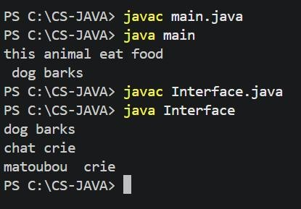
Interface
interface Animal
{ void sound(); // abstract method
}
class Dog implements Animal
{ public void sound()
{
System.out.println("dog barks "); }
}
class chat implements Animal
{ public void sound()
{
System.out.println("chat crie "); }
}
class matou extends chat
{ public void sound()
{
System.out.println("matoubou crie "); }
}
public class Interface
{ public static void main(String[] args)
{
Animal a = new Dog(); Animal b = new chat();
chat m = new matou(); a.sound();
b.sound();
m.sound();
}
}
Output Conclusion
In conclusion, interfaces and simple classes with constructors both help in implementing object-oriented programming concepts in Java. An interface
In conclusion, interfaces and simple classes with constructors
both help in implementing object-oriented programming concepts in
Java. An interface defines methods that classes must implement,
allowing abstraction and polymorphism. In the example, Dog, chat,
and matou provide different implementations of sound(). A simple
class with a constructor, on the other hand, is mainly used to
initialize objects when they are created. Thus, interfaces
provide a common structure for different classes, while
constructors initialize the data of each object.

